Group 13

Author: 任怡静

User Manual

Painkiller Injection System

Table of Contents

System Architecture 2

Nurse Manual 2

Patient Manual 6

## System Architecture

The system architecture is shown below:

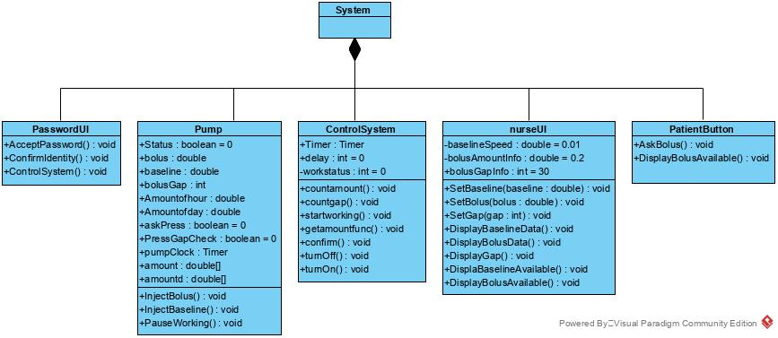

## Nurse Manual

The nurse has a Password UI and nurse UI which are shown below:

1. **The Password UI**

Input your ID and password.

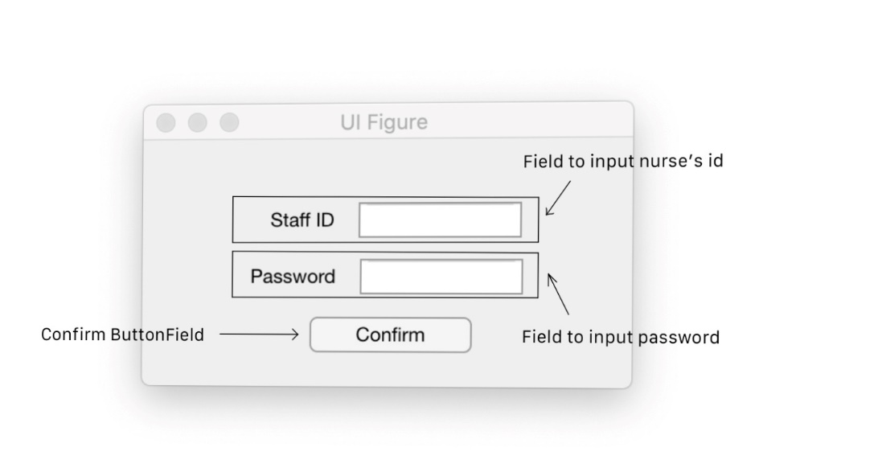

1. **The nurse UI**

You can setup the baseline per minute, bolus per shot and bolus gap between two bolus requests. Then press the ‘Confirm’ button.

Your setting is displayed in the middle. The injection history is displayed on the right.

The baseline available light will show whether the baseline is available, the bolus available light will show whether the bolus is available for quick understanding.

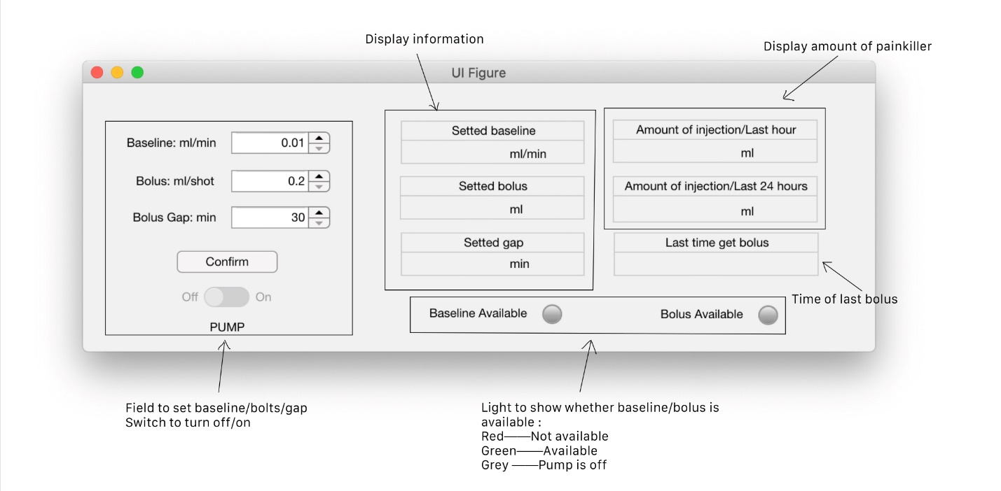

#### Entering the nurse UI

**Step 1:** Enter your ID and password to the system. **Initially, we have an administrative account for you: The ID is 9999 and password is 9999**

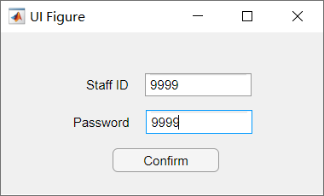

**Step 2:** Press Confirm and then you should be able to see the nurse UI

**Notice:** If wrong ID and password is entered, you will get a warning like below, please confirm your ID and password are consistent, and repeat step 1 to 2.

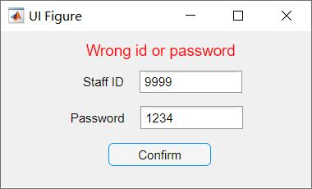

#### Setting up the baseline per minute, bolus per shot and bolus gap

**Step 1:** You can set data by pressing the up or down button on the left column of data. The baseline per minute is limited to 0.01ml/min to 0.1ml/min, the bolus per shot is limited to 0.2ml/shot or 0.5ml/shot, the bolus gap is limited to 30min to 60min, you cannot input data over or below them.

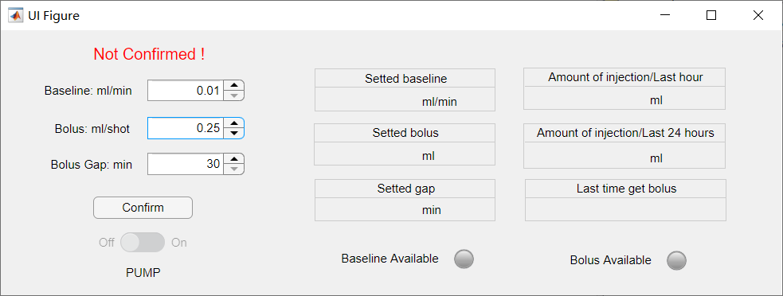

**Step 2:** Press Confirm button to upload the data to Control System, the data is also displayed in the middle column for inspection.

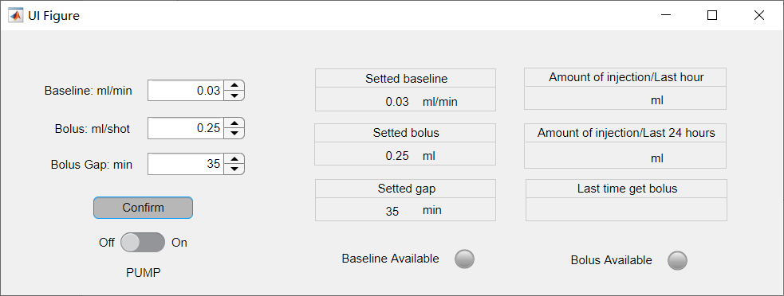

**Notice:** You must press Confirm button to enable the Start button, also to get rid of the warning.

**Step 3:** Switch the On/Off button to On, and the injection begins

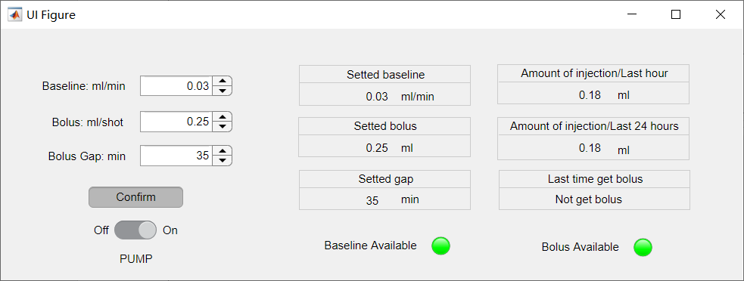

#### Interchanging information

**Step 1:** You can change the value **in the injection process** by pressing the up or down button on the leftmost column.

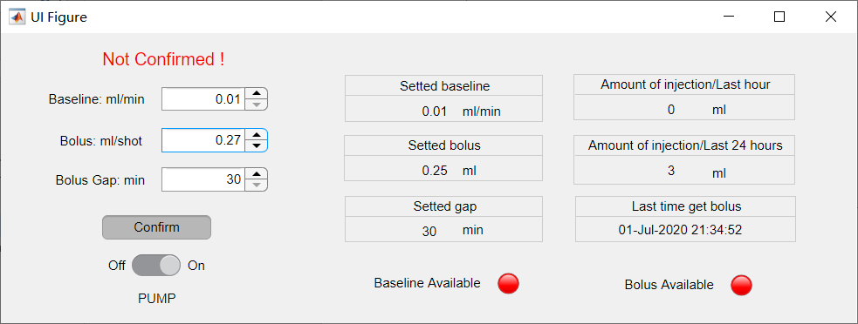

**Step 2:** If you **do not want to change the message** and want to get rid of the warning of Not Confirmed, you can change the values back.

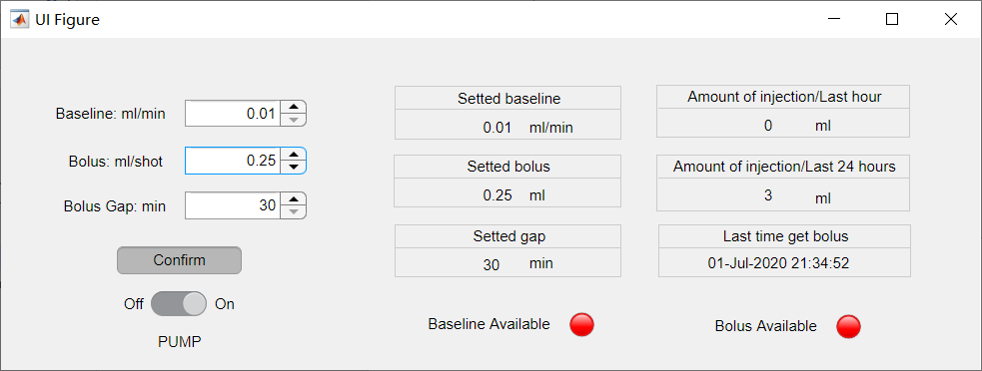

But if you **are sure to change the value**, you need to press Confirm to send the data into the Control System, for which your input value will be valid for the later process, otherwise the later process will still obey the values before your changes.

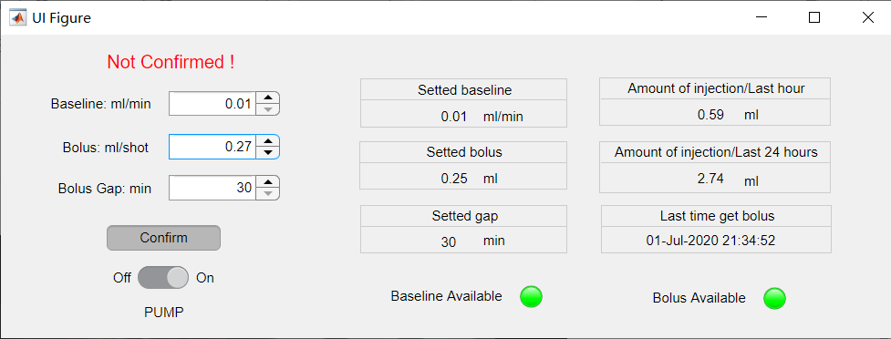

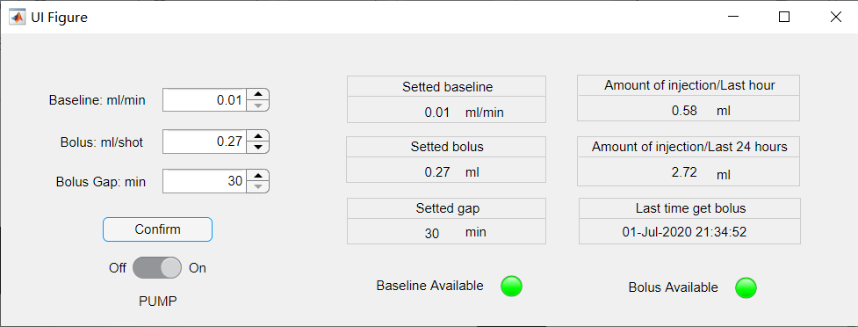

#### Shut down the machine

Switch On/Off button during the injection process will shut down the machine immediately under any circumstances.

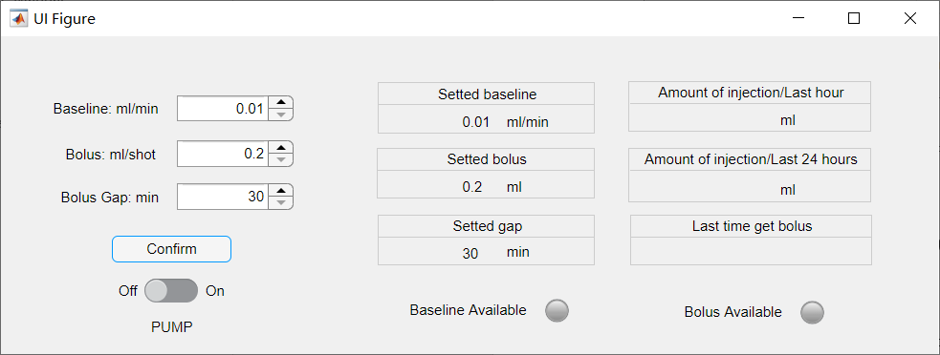

***If you have any problem during the injection, please call us at 123-456-789.***

## Patient Manual

The patient has a PatientButton UI which is shown below

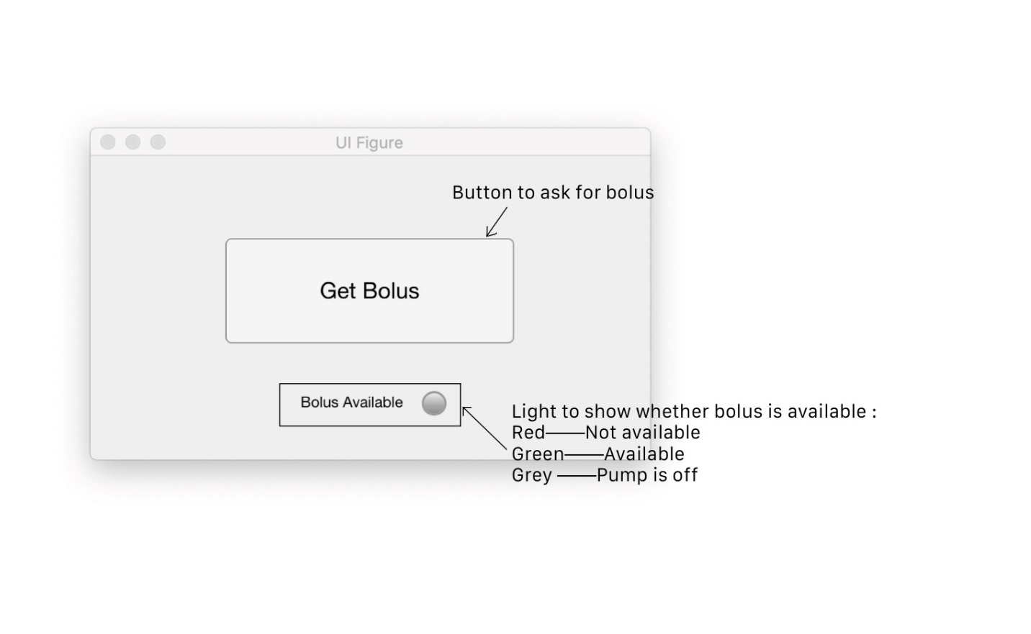

#### Require Bolus

You can require bolus by pressing the Get Bolus button

You can only get bolus when the Bolus Available light bulb is Green

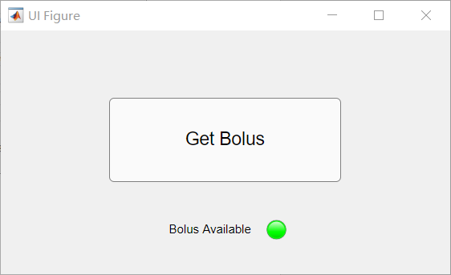

After the button been pressed, the Bolus Available will be Red and you will not receive another bolus until the time interval between two boluses is bigger than the set Bolus Gap

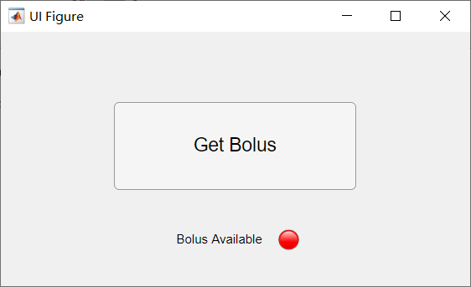

The Control System will give the last time frame of bolus and the availability of bolus to the Nurse UI for inspection and observation.

***If you have any problem during the injection, please consult your doctor or call us at 123-456-789.***